Gigster - A Marketplace for Freelancers

INDUSTRY INTERNSHIP

REPORT

Submitted by

KRISH PATEL

[21162171023]

Guided by

Prof. Ravindra Patel

Submitted to

Faculty of Engineering and Technology
Institute of Computer Technology

Ganpat University





Ganpat University, Mehsana

[June 2025]

CERTIFICATE

This is to certify that the Industry Project work entitled “Gigster - A Marketplace for Freelancers” by Krish Patel (Enrolment No. 21162171023) of Ganpat University, towards the partial fulfillment of requirements of the degree of Bachelor of Technology – Computer Science and Engineering, carried out by in the CSE(CS) Department at iConsultify Solutions LLP. The results/findings contained in this Project have not been submitted in part or full to any other University / Institute for award of any other Degree/Diploma.

Name & Signature of Internal Guide

Prof. Ravindra Patel

Name & Signature of Head

Prof. Dharmesh Darji

Place : ICT – GUNI

Date :

ACKNOWLEDGEMENT

The industry internship project has been a valuable learning journey, helping me grow both technically and personally. I’m truly thankful for the support and guidance I received throughout this experience.
I would like to express my sincere gratitude to Dr. Rohit Patel, Principal of ICT, and Prof. Dharmesh Darji, Head of the ICT Department, for giving us the opportunity to undertake this project.
A heartfelt thanks to Prof. Ravindra Patel for mentoring me on my project Gigster – A Marketplace for Freelancers. His guidance and encouragement kept me focused and motivated throughout.
I also appreciate the efforts of the CSE Department for providing timely support, feedback, and the necessary resources that made this journey smoother.

KRISH PATEL (Enrollment No: 21162171023)

ABSTRACT

In the present scenario, everyone focuses on the theoretical knowledge which is not the only and accurate way to study the basics of programming and Software Development Processes. So, one must understand that practical knowledge is also as much as important as the theoretical knowledge. As an Engineer, one must be aware about certain technical process along with that he must be aware of some non-technical work too such as management, effective communication etc. Hence to develop good engineers, our engineering curriculum consists of a course name ‘Internship/Project’ in 8th semester which helps to implement the theoretical knowledge into the practical ideas. Also, along with technical knowledge student also improves his/her non-technical skills. Also, by this training student can revise the topics taught in college curriculum which they can put into practical knowledge. Under this subject I worked on Freelancer Marketplace Website, a consultation and diagnostic platform to develop during this internship. In this project I learnt about many technologies like HTML, CSS, JavaScript, React, NodeJs, MongoDB, Express js etc.

TABLE OF CONTENTS

Content |  | Page Number
 | Title Page | I
 | Certificate | II
 | Acknowledgement | III
 | Abstract | IV
1 | Company Overview | 1-3
2 | Introduction | 4-5
3 | Project Scope | 6-8
4. | System analysis | 9-12
5. | System design | 13-17
6. | Implementation Details | 18-20
7. | Screenshots | 21-26
8. | Conclusion and future work | 27-28
9. | References | 29=30

CHAPTER 1 : COMPANY OVERVIEW

COMPANY OVERVIEW

Introduction
iConsultify is a dynamic digital solutions provider based in Ahmedabad, Gujarat, India. Established in 2018, the company has rapidly evolved into a trusted partner for businesses seeking robust IT and marketing solutions. Specializing in eCommerce development, particularly on the Shopify platform, iConsultify also offers services in web development, mobile app creation, and digital marketing. Their commitment to quality and innovation has enabled them to assist clients across various industries in achieving their digital objectives. ​

Products and Services
iConsultify offers a comprehensive range of services designed to meet the diverse needs of modern businesses:​
- Custom Shopify Development: As certified Shopify experts, iConsultify crafts tailored eCommerce solutions that align with clients' brand identities and business goals.​
- Web Development: The company builds responsive and user-friendly websites, ensuring optimal performance across devices
- Mobile App Development: iConsultify develops cross-platform mobile applications, enhancing user engagement and accessibility.​
- • Digital Marketing: iConsultify provides SEO, PPC, social media, and email marketing services to boost online presence and attract customers.
- • UI/UX Design: They design clean, user-friendly interfaces that enhance usability and overall user experience.

- IT Consultancy: Providing strategic guidance, the company assists businesses in leveraging technology to drive growth and efficiency.​
Through these services, iConsultify empowers businesses to establish a strong digital presence and achieve sustainable growth. ​
COMPANY OVERVIEW

Departments and Functions
During my internship at iConsultify, I observed a collaborative environment where various departments work cohesively to deliver client-centric solutions:​
- Development Team: Responsible for coding and building websites and applications, ensuring functionality and performance.​
- Design Team: Focuses on creating visually appealing and user-friendly interfaces, aligning with client branding.​
- Marketing Team: Handles digital marketing strategies, including SEO, content creation, and social media management, to enhance online presence.​
- Sales and Client Relations: Manages client interactions, project requirements, and ensures customer satisfaction throughout the project lifecycle.​
- Quality Assurance: Conducts thorough testing to identify and rectify issues, ensuring the delivery of high-quality products.​
This structured approach facilitates efficient project execution and fosters a culture of continuous improvement.​
My tenure at iConsultify provided valuable insights into the workings of a modern IT company. The experience enhanced my understanding of web development processes, client engagement strategies, and the importance of cross-functional collaboration. The company's dedication to delivering customized solutions and maintaining high standards of quality left a lasting impression on me.​

CHAPTER 2 : INTRODUCTION

INTRODUCTION
Gigster is a modern freelancing platform designed to bridge the gap between talented freelancers and clients looking for reliable services. It provides an easy-to-use interface where freelancers can build comprehensive profiles that highlight their skills, experience, and previous work. Freelancers can also list their services, set custom pricing, and manage their availability with ease.
On the other hand, clients get access to a streamlined system to explore freelancer profiles, assess their skillsets, and connect with them directly. The platform includes features such as messaging, project tracking, payment handling, and dispute resolution to ensure smooth project execution from start to finish. Gigster aims to elevate the freelancing experience by delivering a feature-rich environment tailored to meet the needs of both freelancers and clients.
Purpose
- The primary goal of Gigster is to build a digital space that effectively connects freelancers with clients for project-based collaborations.
- It helps freelancers find work by allowing them to showcase their skills and services.
- For clients, it serves as a central platform to find skilled professionals, manage projects, and ensure timely payments.
Objectives
- Bridge Freelancers and Clients: Create a space where freelancers can display their expertise and get hired for suitable projects, while clients can find trusted professionals for their needs.
- Simplify Project Management: Enable both parties to manage all aspects of the project in one place—from communication to payment.
- Build a User-Friendly Platform: Design an interface that’s intuitive and accessible, even for first-time users.
- Ensure Secure Transactions: Safeguard sensitive information and facilitate safe and fair payment processes.

CHAPTER 3 : PROJCT SCOPE

PROJECT SCOPE

Scope / Application
The Gigster platform includes the following key features:
- Freelancer Profiles: Users can create detailed profiles with information on skills, past experience, and portfolio work.
- Service Listings: Freelancers can offer services with clear descriptions, pricing, and availability.
- Order Management: Clients can view services, place orders, and manage ongoing work from their dashboard.
- Messaging System: A built-in chat feature allows seamless communication between clients and freelancers.
- Gig Listings: Freelancers can post their services (gigs) with detailed descriptions, pricing, and timelines. Clients can browse and choose suitable freelancers based on their requirements.
- Search & Filters: Clients can search for gigs using various filters like category, price, and ratings. Freelancers can also filter available jobs based on their skills.
- Secure Payments: The platform supports safe and encrypted payment processing.
- Review System: After project completion, clients can rate and review freelancers to maintain transparency and trust.

Technology Stack
- Frontend: HTML, CSS, JavaScript, Bootstrap, React
- Backend: Node.js, Express.js
- Database: MongoDB

PROJECT SCOPE
Project Development Approach
The development of Gigster started with understanding basic guidelines provided by the company, which included coding standards and best practices.
- Frontend Training: We began with foundational training in HTML, CSS, and JavaScript to build the structure and behavior of web pages.
- Bootstrap: We learned Bootstrap to accelerate UI design and maintain consistency across the platform.
- Database Training (MongoDB): We were introduced to database concepts, with a focus on MongoDB for managing data effectively.
  - Topics included database design, data storage, and retrieval operations.
- React Basics: To build dynamic and interactive web interfaces, we were trained in core React concepts such as components, state, and props.

CHAPTER 4 : SYSTEM ANALYSIS

SYSTEM ANALYSIS
Current system study & problem overview
Gigster is an online freelancing platform designed to connect talented freelancers with clients looking for services across various domains. It serves as a bridge that simplifies the entire freelancing process – from showcasing skills to managing proposals and project communications.
The current traditional freelance engagement process often involves scattered communication, unclear timelines , payment issues and lack of transparency gagster addresses these problems by offering a centralized and secure digital workspace.
Workflow
- Freelancers can showcase their portfolios, browse available projects, submit proposals, and communicate securely with clients.
- Clients can easily post their project requirements, browse freelancer profiles, evaluate proposals, and manage projects.
- The system supports two types of users:
  - Freelancer: Offers services, updates profile details, accepts work agreements, and manages deliverables.
  - Client: Posts new projects, reviews proposals, collaborates with freelancers, and tracks progress.
The Gigster platform plays a significant role in transforming how freelance work is managed and delivered. Here’s how the system benefits each stakeholder:
- Freelancers gain convenient access to a continuous stream of job opportunities, with an intuitive UI to apply and manage tasks.
- They can receive timely updates and clear communication from clients regarding project expectations and payments.
- Freelancers can securely share work updates, progress milestones, and invoices with clients—enhancing transparency and client trust.
- Clients can efficiently post new projects, manage communication, and monitor the status of ongoing work, all in one place.
- The system automates key administrative functions like proposal management, project tracking, and basic accounting.
- Secure, built-in messaging and document-sharing features allow freelancers and clients to collaborate effectively regardless of location.
- Project histories and freelancer performance records are stored centrally, helping both clients and the admin make informed decisions.
- Overall, Gigster improves the workflow, accountability, and satisfaction of both freelancers and clients.

User Characteristics

Freelancer Users
- Can register by providing personal and professional information such as skills, past experience, and portfolios.
- View open projects, submit proposals, accept contracts, and deliver work directly via the platform.
- Can update their profiles, track project statuses, upload work-related files, and generate invoices.
- Receive notifications regarding proposal approvals, payments, and client feedback.

Client Users
- Can create a profile and post project requirements in different service categories.
- Able to review freelancer applications, conduct discussions, and award contracts.
- Can track progress, request revisions, and share necessary project documentation.
- Also able to manage past and ongoing projects from a single dashboard.

System Features
Login and authentication
- A login page for both freelancers and users using email-password with role based dashboard refirection
- Secure authentication using otp verification via email on every login attempt and hased passwords and jwt tokens
- Reset password , resend otp also include
Freelancers Dashboard
- Freelancers can manage their profile , view available orders , post gigs and track their work
- Access client communication threads and update status on assigned orders
- Freelancer can reset their password
Client dashboard
- Client can browse freelancers listings and assign tasks
- Communicate securely with freelancers
- Client can reset the password if they forgot

CHAPTER 5 : SYSTEM DESIGN

SYSTEM DESIGN
Use case diagram
Sequence diagram

Sequence diagram for seller

Activity Diagram
User open gagster site

CHAPTER 6 : IMPLEMENTATION DETAILS

IMPEMENTATION DETAILS
Frontend Enhancements
- New Pages:
  - Gig Add Page: Users can now create and post new gigs.
  - Gig Show Page: This page provides a consolidated view of all available gigs.
  - Specific Gig Detail Page: Users can click on a gig to see detailed information.
- User Interface Improvements: I have refined the overall layout and interactive elements to make the user experience smoother and more engaging.
UI/UX Enhancements
- The platform’s design has been made more responsive and interactive. Enhancements include smoother transitions, better feedback on user actions,

Backend Development
- Technology: I have chosen Node.js
- APIs Developed:
  - Login & Register APIs: authentication to manage user sessions.
  - Gig Management APIs: Endpoints for adding new gigs, fetching gig listings, and retrieving details of specific gigs.
- Integration: These APIs ensure seamless communication between the frontend and backend, supporting dynamic content updates.

- Forgot Password Flow:
  - Users can now securely reset their password using OTP verification sent to their registered email.
  - Depending on success or failure, they are redirected appropriately with clear status messages.
- Role-Based Redirection After Login:
  - Based on whether the user is a client, freelancer, or admin, the system
  - redirects them to their respective dashboards upon successful login.
- Secure Registration with Extended Fields:
  - The registration form was enhanced to include additional details such as address, date of birth, and user role to support profile enrichment and analytics.
- Activity Logging & Logs Dashboard:
  - For admins, a new log management feature was added where system events (e.g., logins, registration attempts, gig creation) are recorded and can be viewed on the dashboard.
- Project Stats & Appointment Booking (Upcoming):
  - API integration has started for real-time stats and appointments, laying the foundation for the upcoming booking flow between clients and freelancers.

CHAPTER 7 : SCREENSHOTS

SCREENSHOTS
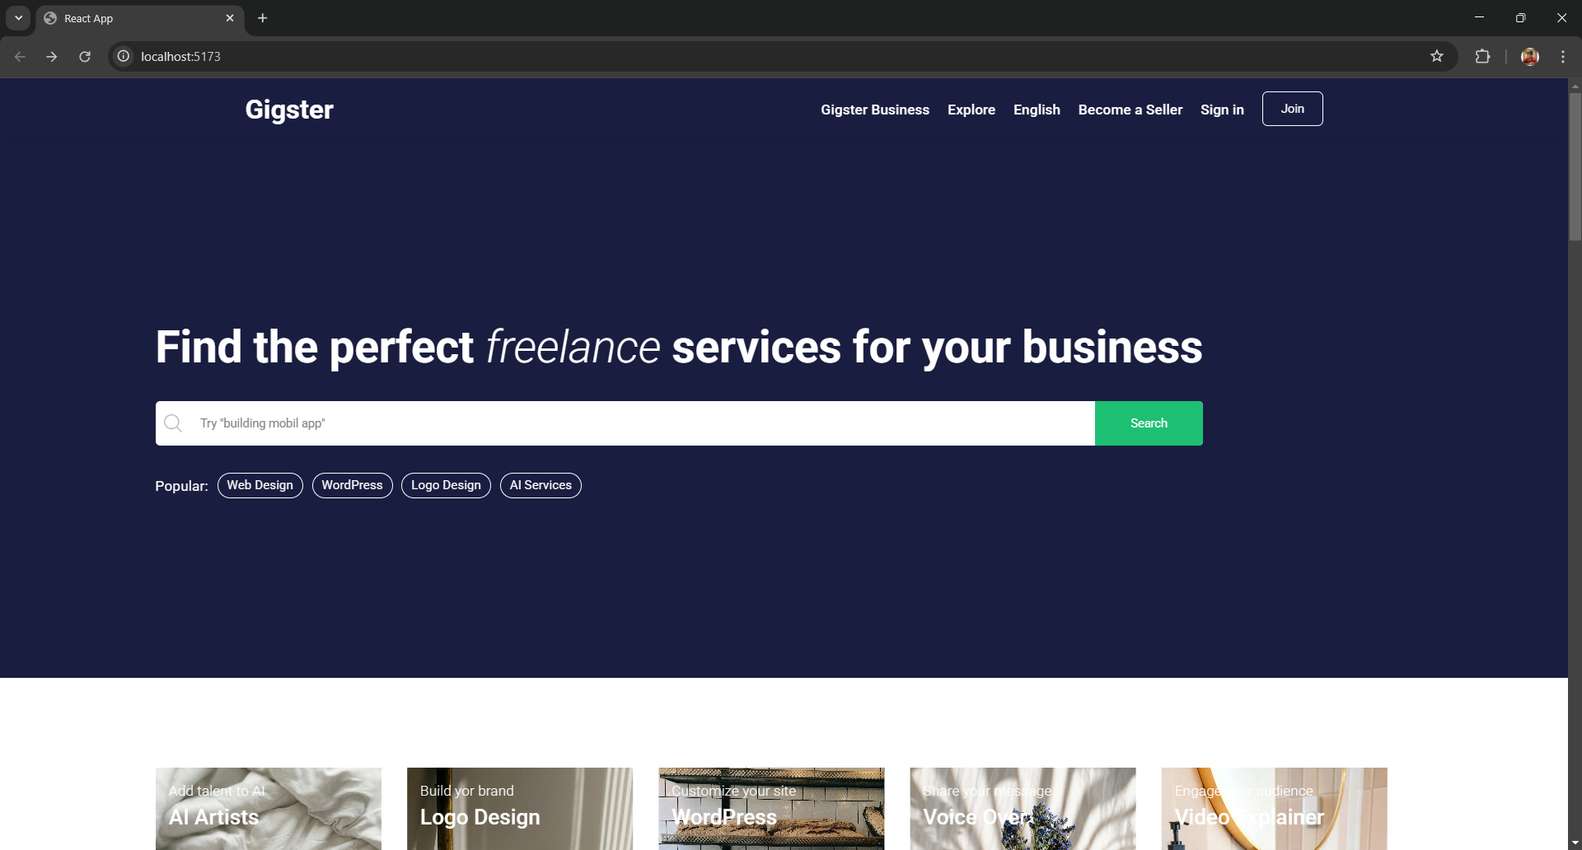
Figure 1 home page

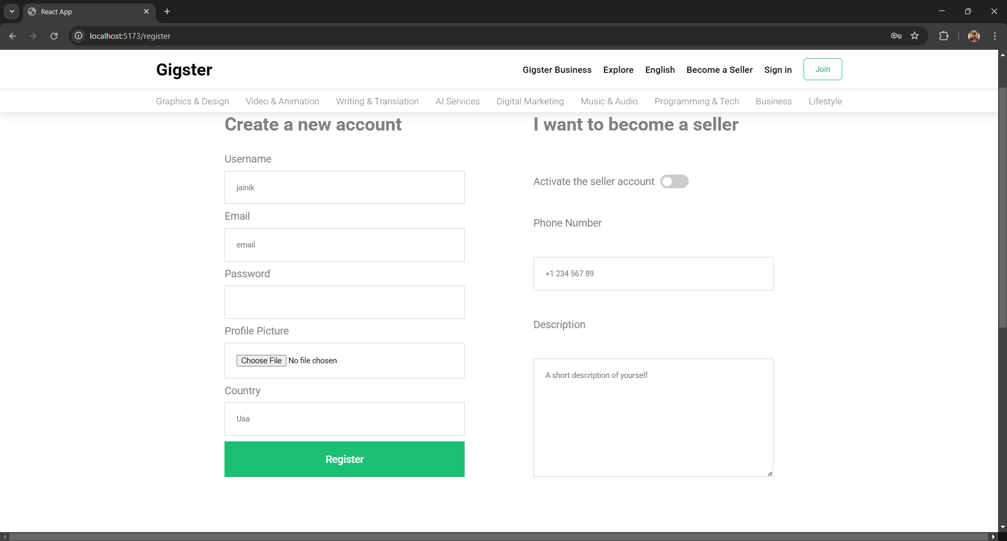
Figure 2 register page

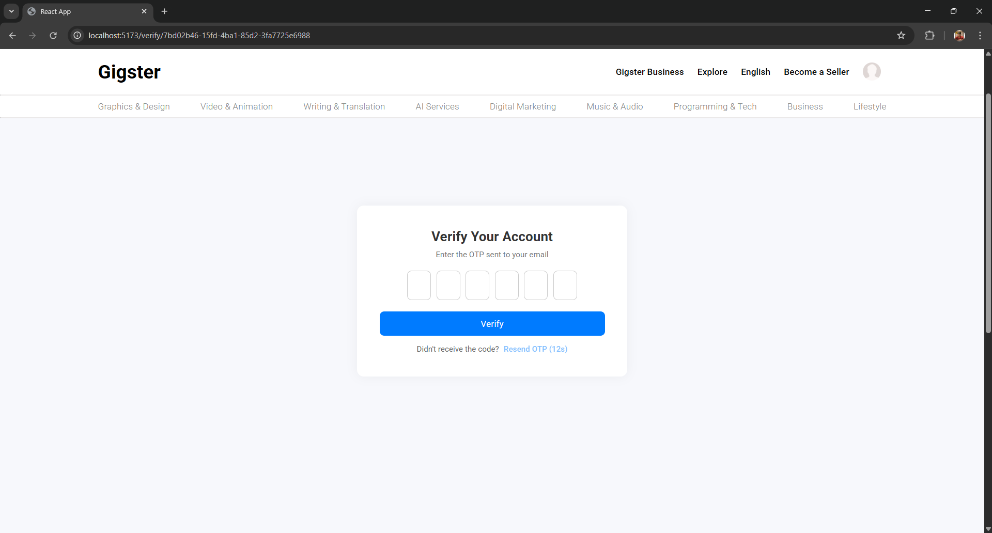
Figure 3 Account Activation page

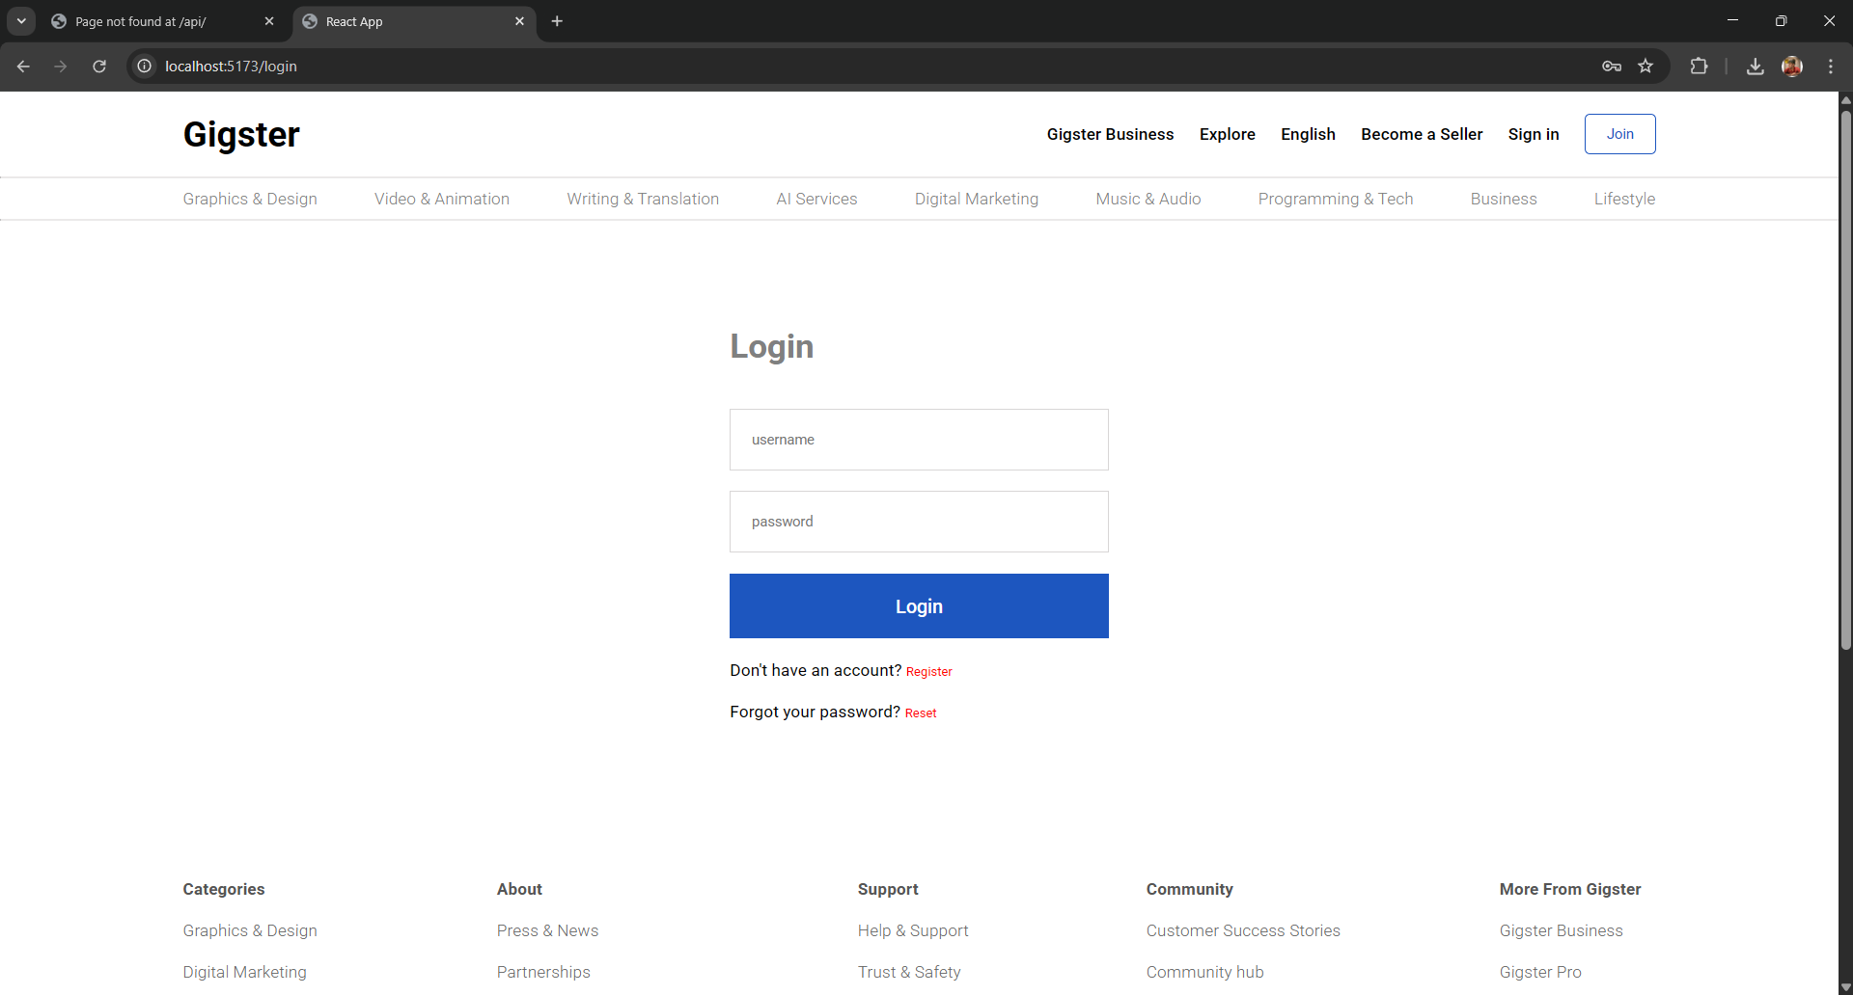
Figure 4 Login Page
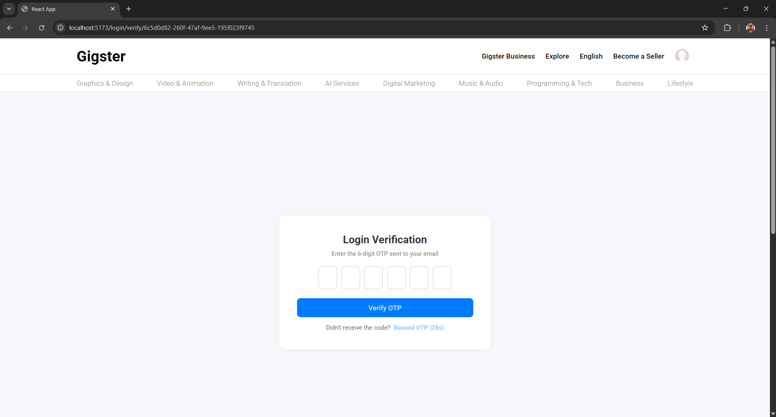
Figure 5 Otp Verification Page

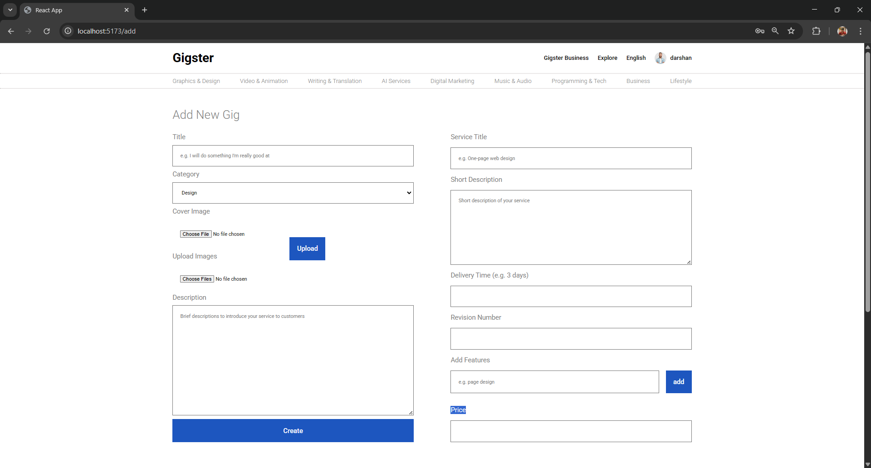
Figure 6 Gig Add Page
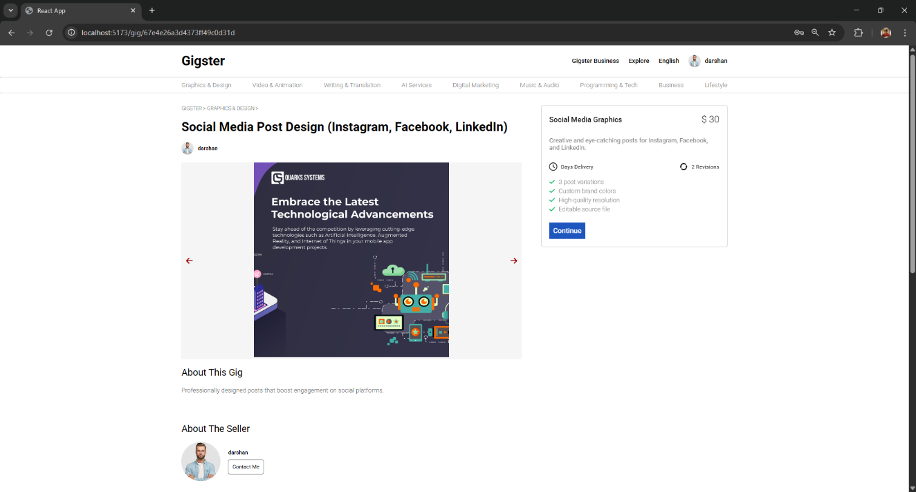
Figure 7 Individual Gig Detail Page

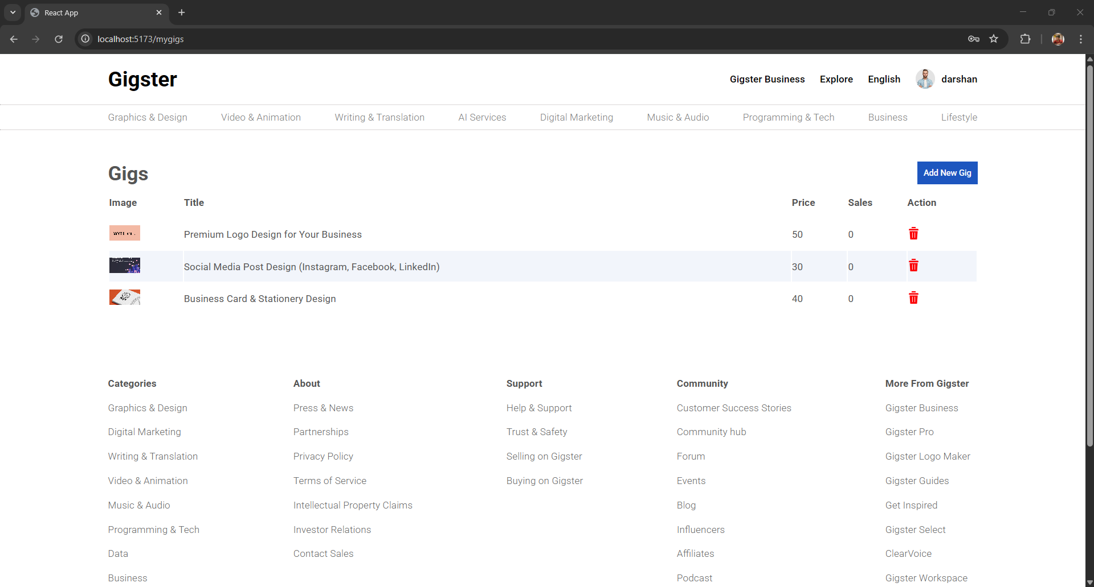
Figure 8 Gig Manage Page

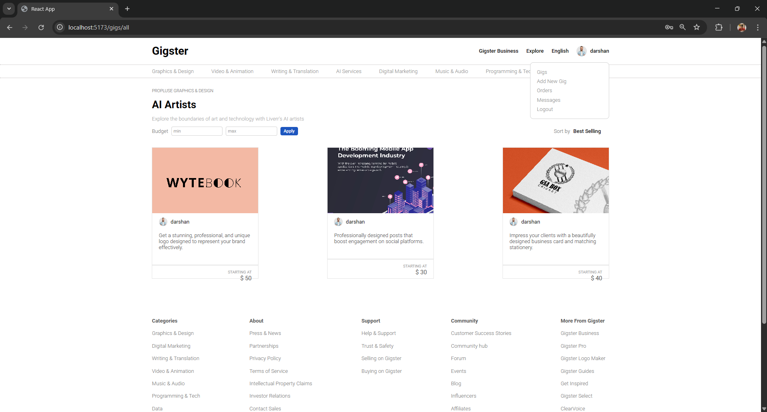
Figure 9 Listed Gig Page

CHAPTER 8 : CONCLUSION

CONCLUSION
The Gigster platform has grown into a dynamic and reliable freelancing hub that bridges the gap between gig seekers and service providers. Built with a modern tech stack—React.js on the frontend and Node.js on the backend—it now delivers a streamlined, secure, and responsive user experience. After incorporating feedback from the second project review, several major enhancements were made, including user role-based redirection, OTP-based authentication, activity logging, and real-time display of project and user data.
Users can now browse gigs, create their own listings, manage profiles, and interact through a basic messaging system that supports sending and receiving messages. The integration of the Stripe payment gateway has also made it possible to conduct secure transactions within the platform, marking a significant milestone in transforming Gigster into a professional-grade tool for freelancers and clients alike.
Future Work
Although Gigster now handles core freelancing functionalities effectively, there is still much room for refinement and expansion. Planned features for upcoming development phases include:
- Advanced Messaging System: Building on the current basic chat, we aim to introduce message timestamps, read receipts, message history storage, and real-time notifications to enhance communication reliability.
- Project-Based Booking Flow: Implement a structured workflow where clients can not only post gigs but also formally book freelancers, define milestones, and track progress step-by-step.
- Gig Search Optimization: Add smart filters such as budget range, skill level, project duration, and availability to help users discover relevant gigs or freelancers faster and more accurately.
- Dispute Management System: Provide admins with tools to handle disputes between clients and freelancers, with access to communication history and project logs for resolution.
- Notification Center: Introduce in-app and email notifications for critical actions like gig assignments, new messages, payment updates, and account changes.
- User Analytics Dashboard: Offer insights to both freelancers and clients with data visualizations on project performance, earnings, engagement rates, and user activity trends.
By implementing these upcoming features, Gigster will continue evolving into a comprehensive freelancing platform that supports trust, transparency, and long-term professional collaboration.

CHAPTER 9 : REFERENCES

REFERENCES

MongoDB. "MongoDB Manual." Available online: https://docs.mongodb.com/manual/

Express.js. "Express - Node.js web application framework." Available online:

https://expressjs.com/

React. "React - A JavaScript library for building user interfaces." Available online:

https://reactjs.org/

Node.js. "Node.js." Available online: https://nodejs.org/

Redux. "Redux - A Predictable State Container for JS Apps." Available online:

https://redux.js.org/

JWT.io. "JSON Web Tokens." Available online: https://jwt.io/

Cloudinary. "Cloudinary - Image and Video Management for Developers." Available : https://cloudinary.com/

Stripe. "Stripe - Online payment processing for internet businesses." Available online:

https://stripe.com/

vite : https://vite.dev/guide/

Youtube : https://youtu.be/RGKi6LSPDLU?si=OlIcm-hf1U8mHSxN

https://youtube.com/playlist?list=PLu71SKxNbfoDqgPchmvIsL4hTnJIrtige&si=eoAY1BS-gVwVO_3h

Plagiarism Report

